Software Requirements Specifications (SRS)
for Mobile Application for Health Care

Vignesh M (71382002138)
CSE ‘C’ 3rd year

TABLE OF CONTENTS:

- INTRODUCTION
- PROBLEM STATEMENT
- METHODOLOGY
- HARDWARE AND SOFTWARE REQUIREMENTS
- WORKING OF THE SYSTEM
- UML DIAGRAMS
- SCREEN SHOTS
- RESULT
- SCOPE
- CONCLUSION
- REFERENCES

INTRODUCTION
In this day and age, it is now difficult for anyone to know what life is like. Since health care is invisible and untreatable, people are at greater risk for health problems. Health care is the maintenance and monitoring of health through prevention, diagnosis and treatment. This was introduced by health and medical professionals such as doctors and nurses. However, in many parts of the world, such health care is still widely available despite advances in technology and health care. Another problem is the extra cost of post-operative care and post-hospital care. After the patient is discharged, home follow-up is equally important and necessary to ensure patient well-being. At home, continuous monitoring of health conditions provides caregivers with visibility on patients' recovery strategies . Therefore, it should be carefully considered to get it completely. The process of documenting health conditions from time to time is prone to user error. For example, it is possible for a person to forget to take the reading at the right time, or it may also be incorrect. It is also important to treat the patient on time. However, it is possible to give the wrong pill or forget to put the medicine on top. These activities can be made easier by creating a system that informs them about their medications. The adoption of Internet of Things (IoT) in health care can greatly improve patient care and reduce user errors .IoT is a system of connected devices that can exchange data. This allows them to make wise decisions about growth and development in the Internet of Things, better and better health care is now possible and easily accessible. The integration of IoT into health care can significantly reduce mortality, and ensure patient-centered care. With the integration of IoT in health care, it is possible to get a faster and more accurate diagnosis of diseases and to find the best solution for them .The concept of the proposed paper is to define and implement a real-time health monitoring system using the Internet of Things (IoT) and a smart phone system. The system contains sensors that monitor various health factors such as blood pressure, electrocardiogram (ECG), heart rate, body temperature, and oxygen saturation (SpO2). The app displays information from the sensors from time to time in a simple way that is understandable to all.

PROBLEM STATEMENT
Monitoring an individual's health is considered important because of the increasing health problems in today's world. A growing stressful life takes a heavy toll on public health. As the queue grows in hospitals and the number of patients is increasing, doctor's fees have skyrocketed, especially for those patients who are unable to pay or who are not in large patients but who only know that after paying the doctor's fee .Remote health monitoring can provide useful physical information at home. This precaution is helpful for elderly or chronically ill patients who may wish to avoid hospital stays. The system should collect the diagnosis of heart disease, blood pressure, temperature data and a few other parameters .This program provides better health care for self- monitoring and consultation from a specialist. The customized app will be extremely useful for users of any age. Easy to present the app to the user will be the key to the success of this program.
The objectives of the proposed paper is :
  - To remotely detect body temperature, blood pressure and pulse rate of an Individual using wearable sensor.
  - To transmit these information to the concerned hospital and Doctor.
  - To ensure data readability of the sensors where anybody can easily identify the status of the health without any prior technical knowledge.
  - To provide a fast responding alert mechanism and timely medical help for critically ill patients.
  - The proposed health monitoring system is compatible with the use of a variety of wearable sensors to extract medical data that helps determine multiple parameters such as pulse rate, blood pressure, and body temperature, ECG at the same time.

METHODOLOGY
The proposed system is to record various sensory information and present it to users in an easy-to-use interface. Recorded data that can be accessed through the app will show that the reading is within the normal range. It will also inform the user and their contacts regarding medication requirements such as dosage, meal time etc. In the next section, the building blocks will be specified. The proposed system consists of sensors that monitor various health parameters, namely heart rate, blood pressure, electrocardiogram (ECG), body temperature and oxygen saturation (SpO2).

HARDWARE AND SOFTWARE REQUIREMENTS

Hardware Requirements:
The hardware and software requirements for implementation of the proposed system is blood pressure sensor, temperature sensor, ECG sensor, heart rate, and Blynk App.

Blood Pressure Sensor:
BPS is a clinical sensor used to detect and measures the human blood pressure. It can measure systolic, diastolic and mean arterial pressure using an oscillometer process. Monitoring blood pressure is important because as it rises, it builds up in the bloodstream and thus weakens it. For these reasons, the risk of stroke, heart disease, and dementia is possible. Blood pressure refers to the force exerted by the blood flow to the atrial wall during congestion and diastole. A strong tendency to have high blood pressure (hypertension) is considered an early symptom that often helps medical professionals diagnose large patients.

Pulse Oximeter and Temperature Sensor (MAX30102):
The MAX30102 pulse oximeter is used in the proposed construction to measure temperature and oxygen saturation. The pulse oximeter is a non-invasive test that uses a probe that can be protected by a finger or an ear. It measures the level of oxygen in the blood. Typical oxygen saturation levels are between 95 and 100 percent. Low oxygen levels below 90 percent can cause cells to become depressed and damaged. The pulse oximeter is used to monitor the health conditions of a patient with problems affecting blood oxygen levels such as anemia, heart disease, heart failure etc. MAX30102 is a pulse oximetry solution and a heart rate sensor solution. It includes two LEDs (IR and Red), a picture detector (visible + IR), well-designed optics, and low-frequency signal operation to detect pulse oximetry and heart rate signals. It is completely configurable using software registers, and digital output data is stored in 32 deep FIFOs within the device.

ECG Monitoring Sensor (AD8232):
The AD8232 ECG was approved to measure cardiac output at rest. The ECG (Electrocardiogram) provides details such as heart rate and rhythm. It can also provide information on increased heart rate due to high blood pressure (hypertension), symptoms of decreased oxygen supply to the heart, increased muscle mass in the heart, and may indicate signs of previous heart attack. The AD8232 ECG Module is integrated with the AD8232 IC from Analog Devices, which is a single-chip designed to extract, amplify, and filter powerful bio signals for potential bio- measurement applications (such as ECG and others). ECGs can be excessively sound so that the AD8232 Single Lead Heart Rate Monitor can act as an op-amp to help get clear signal from PR and QT intervals easily.

Microcontroller (ESP32):
ESP32 is a highly flexible chip (SoC) system that can be used as a standard purpose microcontroller with a wide set of parameters including wireless capabilities. And it can be implemented as an excellent solution for a mass production bed. ESP32 can act as a completely independent program or as a slave device on the host MCU, reducing the communication stack over the main application processor. ESP32 can connect to another application to provide Wi-Fi and Bluetooth functionality with its I2C / UART port.

LCD Display:
In this automated system for monitoring wireless health in patient hospitals, an LCD display is used to monitor a patient's body temperature. This LCD display connects to the microcontroller and is powered by 5V dc with a voltage regulator. This LCD display has 16 pins.

Buzzer:
A buzzer or beeper is an audio signature tool, which can be mechanical, electromechanical, or piezoelectric (piezo for short). Typical uses of buzzers and beepers include alarm devices, timers, and user input verification such as mouse click or key.

Software Requirements:

C Programming:
C is the language of process planning. It is designed primarily as a programming language. Key features of the C-language include low memory access, a simple set of keywords, and a clean style, these features make the C- language ideal for programming as a functional program or compiler integration. C combines features of both high and low languages. It can be used to create low-level programming, such as pilots and characters and supports high-level language activities, such as writing software applications, etc. C is a systematic programming language that allows a complex system to be separated from simple systems called functions. It also allows free flow of information across all these functions. C is highly portable and is used for writing programs that make up the bulk of the Windows, UNIX, and Linux operating systems. C is a language that sets common goals and can work well in business plans, games, graphics, and applications that need to be calculated, etc. Language C has a rich library that offers a wide range of built-in functions. It also provides powerful memory sharing. Using algorithms and data frames quickly, facilitates faster calculation of programs.

Working of the System:
The complete set of the proposed system is shown in Figure 8. Details of the blood pressure sensations, heart rate, body temperature, ECG is displayed on the local LCD display, and on android or iOS via the internet. The sensors are connected to the ESP32 microcontroller, which is also connected to the Wi-Fi Shield. The shield is mounted on a microcontroller board and provides internet connectivity throughout the system. The Microcontroller is connected to the components of the hearing unit, the WIFI Module, and is powered by an external battery. The nerves are attached to the patient's body. The proposed system will serve as a real-time monitoring system .Depending on the time-varying adjustment between each reading done in the app, sensory reading is recorded by the system and displayed on the display. Used data is sent to android, iOS application using cloud computing where individual data is stored and monitored. In the event of an emergency, the application will send a notification to patients in that emergency. The measured parameters i.e., blood pressure, pulse rate, body temperature, ECG of a person is displayed on the Blynk app. The sensors details are updated continuously on our mobile application. We can keep a constant watch at our body parameters by using the Blynk App. The medications can be suggested by the doctor even from a distance. The mobile app will also provide a user interface that informs the user about medication that needs to be taken, at a set time. The recording details of the application send it to the LCD display as well as to the appropriate smart app.

UML DIAGRAMS:
USE CASE DIAGRAM FOR ADMIN:

USE CASE DIAGRAM FOR PATIENT:

USE CASE DIAGRAM FOR PATIENT:

CLASS DIAGRAM:

SEQUENCE DIAGRAM FOR ADMIN:

SEQUENCE DIAGRAM FOR PATIENT:

SEQUENCE DIAGRAM FOR PUBLIC:

COLLABORATION DIAGRAM FOR ADMIN:

COLLABORATION DIAGRAM FOR PATIENT:

COLLABORATION DIAGRAM FOR PUBLIC:

STATE DIAGRAM FOR ADMIN:
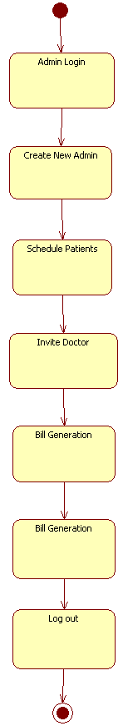

STATE DIAGRAM FOR PATIENT:
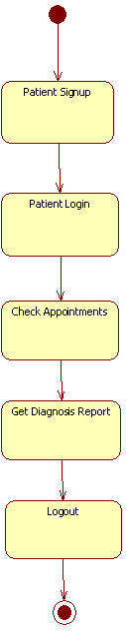

STATE DIAGRAM FOR DOCTOR:
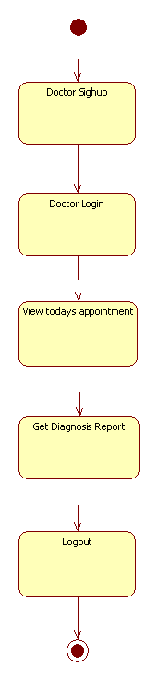

SCREE SHOTS:
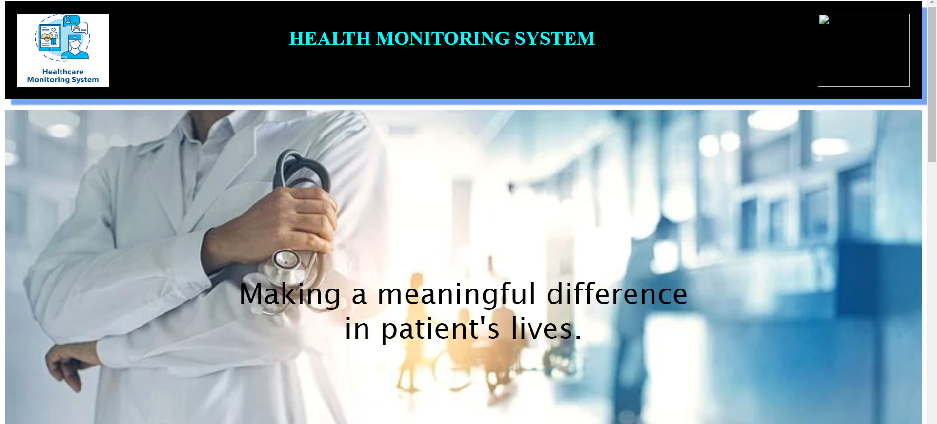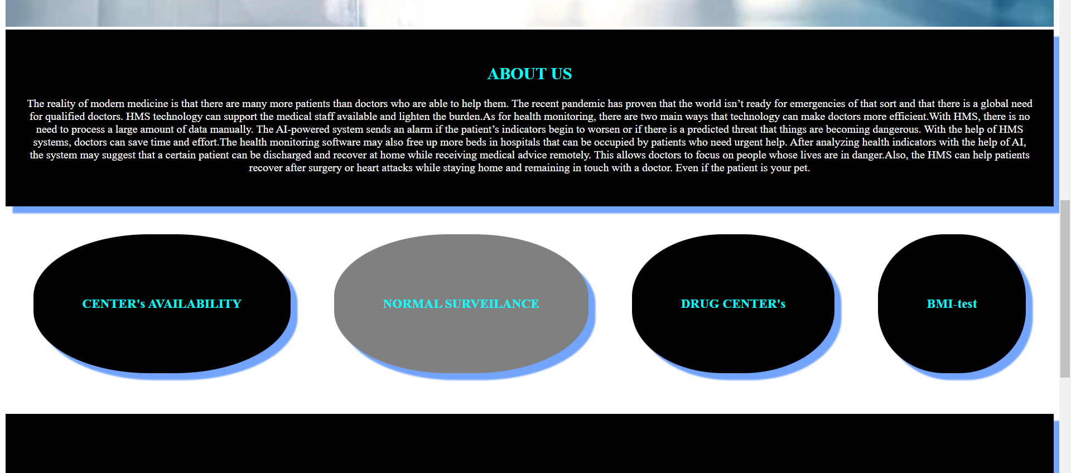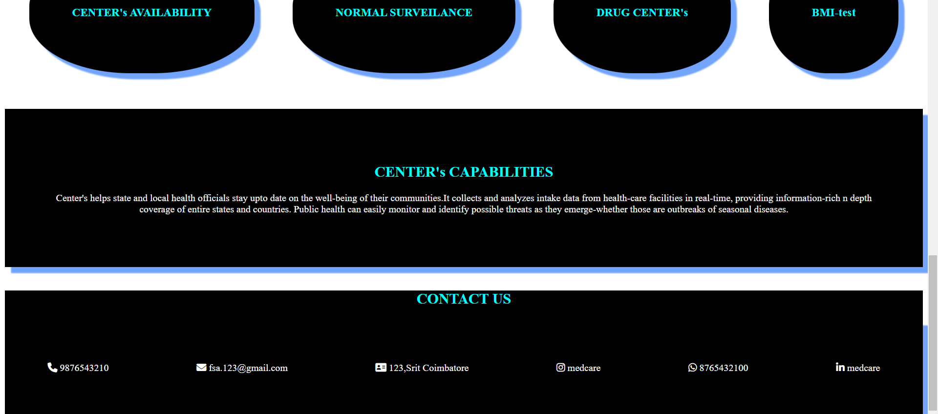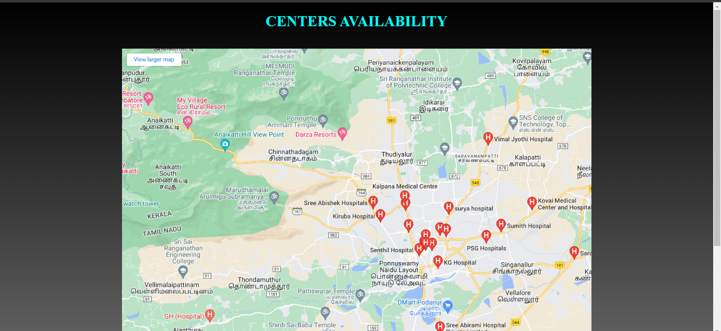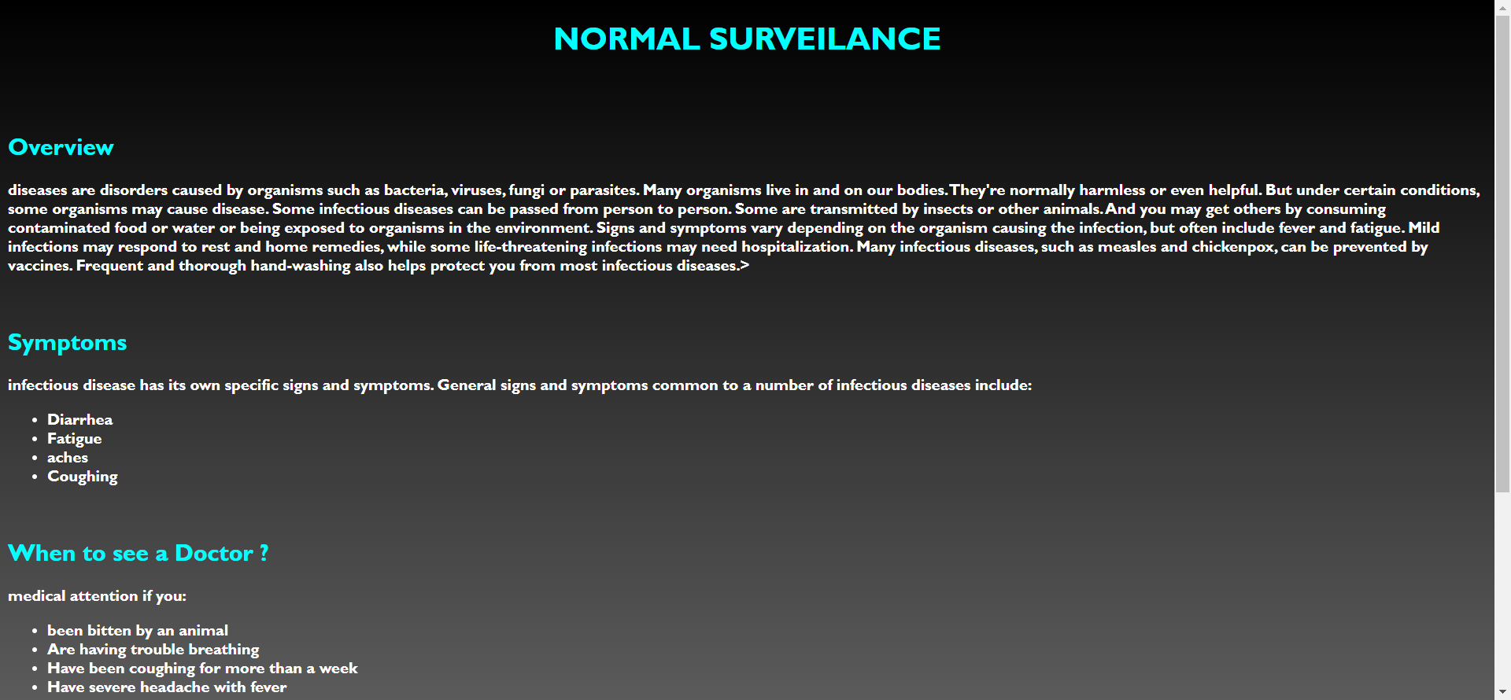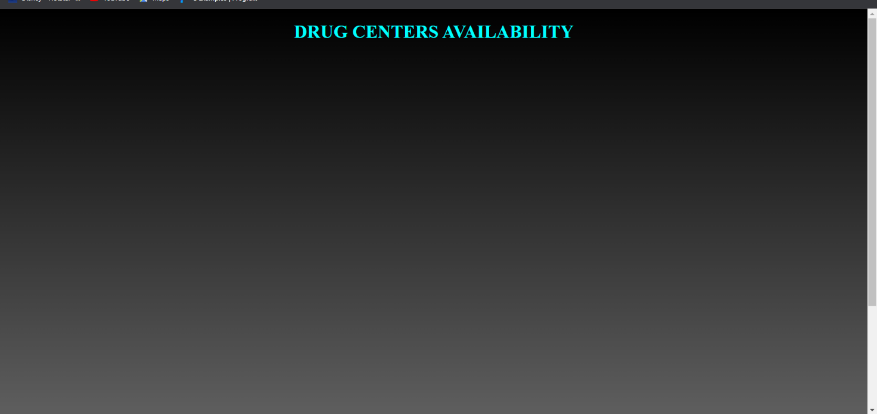

RESULTS AND DISCUSSION
In this proposed paper, the real-life health monitoring system is designed for a variety of health parameters such as blood pressure, heart rate, body temperature and ECG obtained through nerve endings. Details of the temperature and SPO2 sensor are shown on the LCD display as shown below Figure 10. Cardiovascular measurement details are shown on the LCD display as shown in Figure 11. The estimated physical parameters shown remotely in the Blynk app

FUTURE SCOPE
The main advantage is a very simple user interface and fast conversion to CSV files to store real-time data. Real-time data can continue to be analysed using the embedded C system to predict future human health conditions. It is clear that the implementation of such a program will help in early detection of rare cases of cardiovascular disease and prevention of its adverse effects.

CONCLUSION
Remote health monitoring system based on IoT, bearing low cost, portable, energy efficient has given satisfactory results. The system makes the use of sensors along with ESP32 microcontroller and Blynk App. The body parameters of a person sensed by the sensors are sent to the cloud with the help of Wi-Fi shield and the sensor details are displayed on the Blynk mobile application preinstalled on the android phone or ios. The proposed system is very useful and valuable to the society especially the senior citizens since they can have a regular check at their health sitting at their homes.

REFERENCES
- Smart-phone Based Health Monitoring System, Md. Milon Islam, Md. Rashedul Islam, 2019.
- Sensor Based Health Monitoring System, Ashikur Rahaman, Shikh Noouddin, 2019.
- Continuous Heart rate Monitoring System using IoT, Johan Bhurny Bathilde, Rajith Chameera, Dyg Norkhairunnisa Abang Zaidel, 2018.
- A survey on e-health care Heart Monitoring for Heart care using IoT, Suvarna Pawar, Dr. H R Deshmukh, 2018.
- Temperature and Heartbeat Monitoring System using IoT, G. Vijay Kumar, A. Bharadwaj and N. Nikhil Sai, 2017.
- Microcontroller based Health Monitoring System, Muhammad Sheikh Sadi, Md. Milon Islam, Md. Rashedul Islam,2019

